**University of Engineering and Technology ,Taxila**

**Department of Computer Engineering**

# Lab Report 03

**For the Course of DBMS lab**

**Submitted By**:Muhammad Ibrahim (21-CP-26)

**Section:** Omega

## **Lab Instructor:**Sir Shahid Ali

**Course Instructor:**Engr.Sana Ziafat

**Date**: 02-02-24.

## **Course Title**: DBMS Lab

**SQL Constraints**

Constraints are used to limit the type of data that can go into a table.

Constraints can be specified when a table is created (with the CREATE TABLE statement) or after the table is created (with the ALTER TABLE statement).

We will focus on the following constraints:

* NOT NULL
* UNIQUE
* PRIMARY KEY
* FOREIGN KEY
* CHECK
* DEFAULT

**Examples**

**Not Null/Unique:**

**Code:**

--create table Persons_Lab4 (

--P_Id int NOT NULL,

--LastName varchar(255) Not null,

--FirstName varchar(255),

--Address varchar(255),City varchar(255)

--CONSTRAINT uc_PersonID UNIQUE(P_Id,LastName));

--insert into Persons_Lab4

--VALUES(1,'Ibrahim','Nasir88','sgd','sgd');

--insert into Persons_Lab4

--VALUES(2,'Ibrahim12','Nasir77','sgd','sgd');

--insert into Persons_Lab4

--VALUES(3,'Ibrahim34','Nasir66','sgd','sgd');

--insert into Persons_Lab4

--VALUES(4,'Ibrahim55','Nasir5','sgd','sgd');

ALTER TABLE Persons_Lab4

Add Unique (P_Id)

ALTER TABLE Persons_Lab4

ADD CONSTRAINT uc_PersonID UNIQUE(P_Id,LastName)

SELECT * FROM Persons_Lab4;

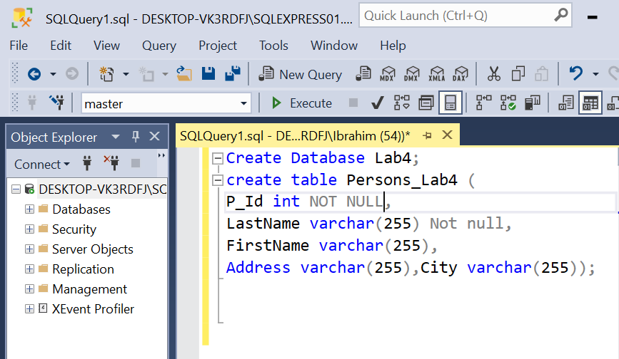

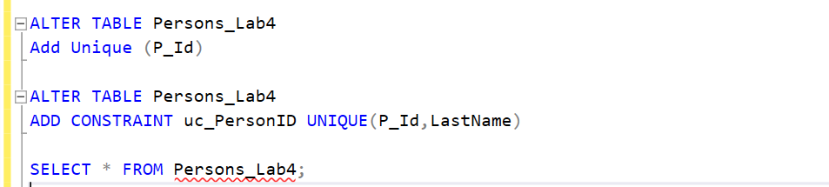

**Constraint on multiple column object :**

**Code:**

create table Persons3_Lab4 (

P_Id int NOT NULL PRIMARY KEY,

LastName varchar(255) Not null,

FirstName varchar(255),

Address varchar(255),City varchar(255)

CONSTRAINT uc_Per UNIQUE(P_Id,LastName));

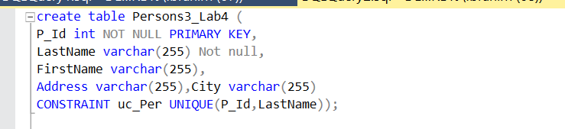

**Alter commands:**

**Code:**

ALTER TABLE Orders

ADD CONSTRAINT fk_PerOrders

FOREIGN KEY (P_Id) REFERENCES Persons3_Lab4(P_Id)

ALTER TABLE Orders

ADD FOREIGN KEY (P_Id)

REFERENCES Persons3_Lab4(P_Id)

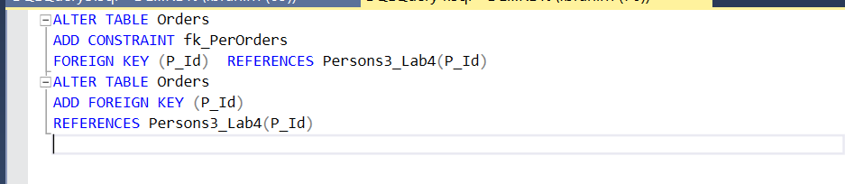

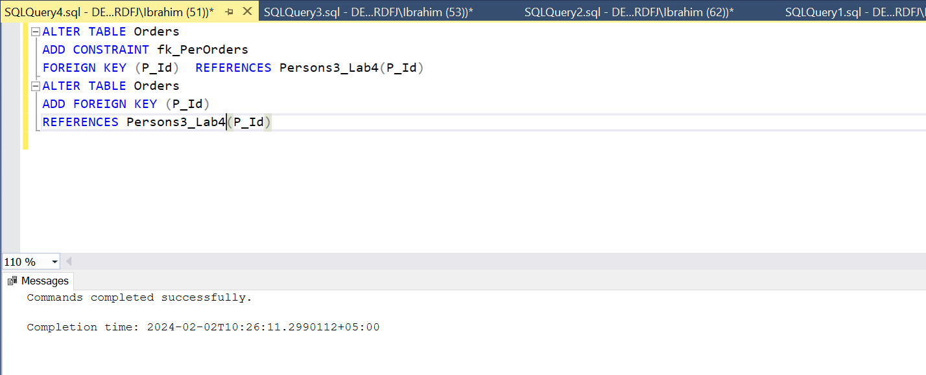

**Foreign/Primary commands:**

**Code:**

create table Persons3_Lab4 (

P_Id int NOT NULL PRIMARY KEY,

LastName varchar(255) Not null,

FirstName varchar(255),

Address varchar(255),City varchar(255)

CONSTRAINT uc_Per UNIQUE(P_Id,LastName));

insert into Persons3_Lab4

VALUES(1,'Hansen','Ola','timovetin10','sanddness');

insert into Persons3_Lab4

VALUES(2,'syendson','Tove','borgen','sandnes');

insert into Persons3_Lab4

VALUES(3,'Petersen ','Kari','Storgt 20','Stavanger');

create table Orders (

O_Id int NOT NULL PRIMARY KEY,

OrderNo int NOT NULL,

P_Id int FOREIGN KEY REFERENCES Persons3_Lab4(P_Id));

insert into Orders

VALUES (1,77895,3);

insert into Orders

VALUES (2,44678,3);

insert into Orders

VALUES (3,22456,2);

insert into Orders

VALUES (4,24562,1);

select * from Orders

select * from Persons3_Lab4

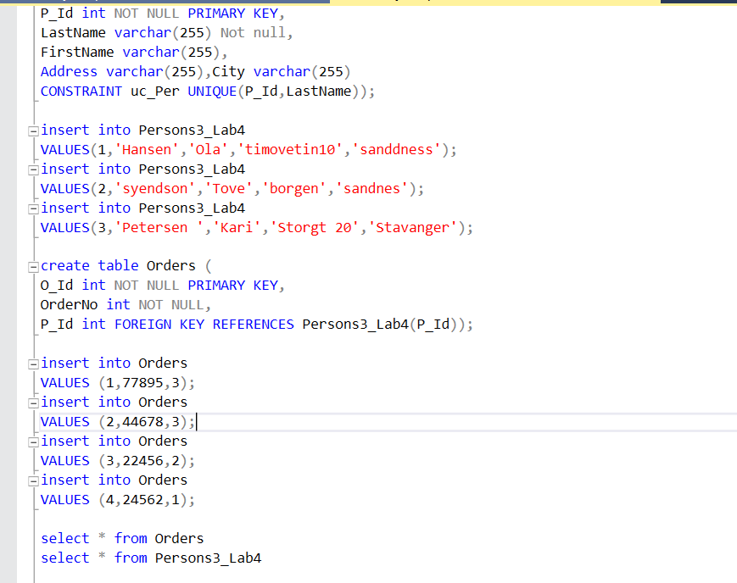

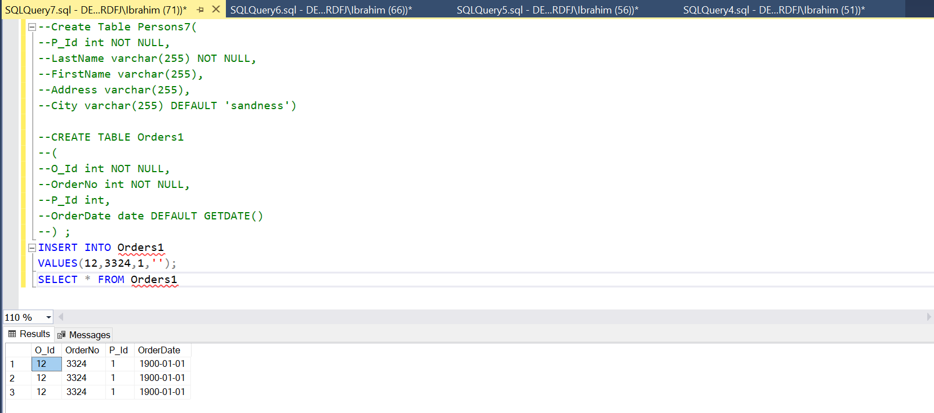

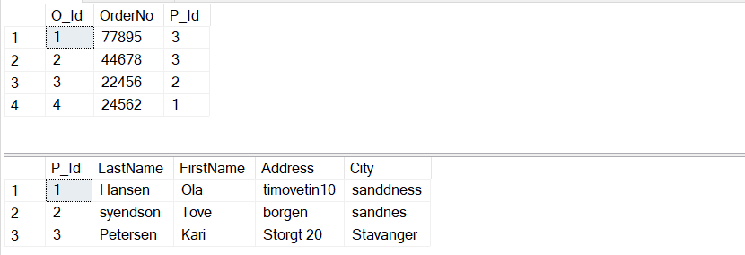

**Check commands:**

**Code:**

Create table Persons5(

P_Id int NOT NULL CHECK (P_Id>0),

LastName varchar(255) NOT NULL,

FirstName varchar(255),

Addresss varchar(255),

City varchar(255)

)

Select * from Persons5

CREATE TABLE Persons6

(

P_Id int NOT NULL,

LastName varchar(255) NOT NULL,

FirstName varchar(255),

Address varchar(255),

City varchar(255),

CONSTRAINT chk_Person CHECK (P_Id>0 AND City='Sandnes')

)

Select * from Persons6

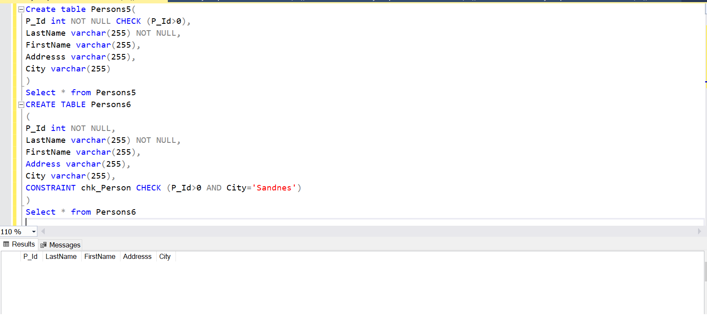

**Default commands:**

**Code:**

--Create Table Persons7(

--P_Id int NOT NULL,

--LastName varchar(255) NOT NULL,

--FirstName varchar(255),

--Address varchar(255),

--City varchar(255) DEFAULT 'sandness')

--CREATE TABLE Orders1

--(

--O_Id int NOT NULL,

--OrderNo int NOT NULL,

--P_Id int,

--OrderDate date DEFAULT GETDATE()

--) ;

--INSERT INTO Orders1

--VALUES(12,3324,1,'');

SELECT * FROM Orders1

select * from Persons7

select * from Orders1

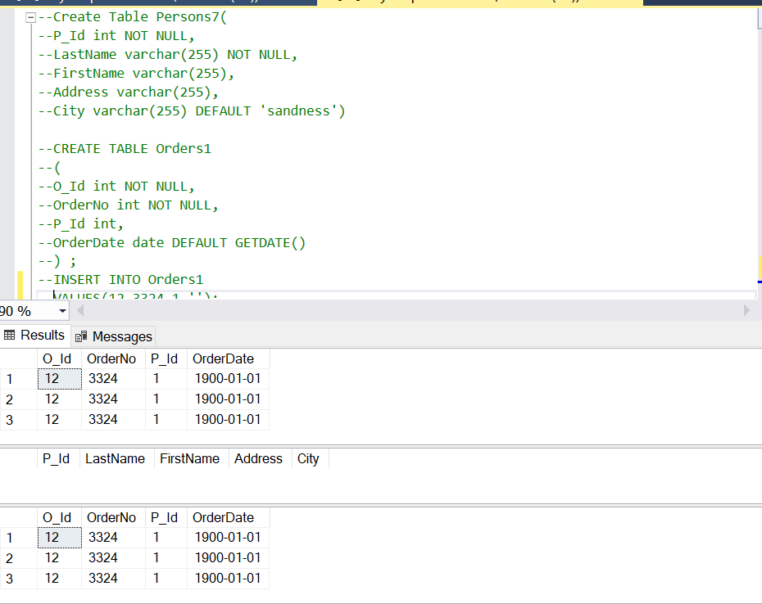

**Task:**

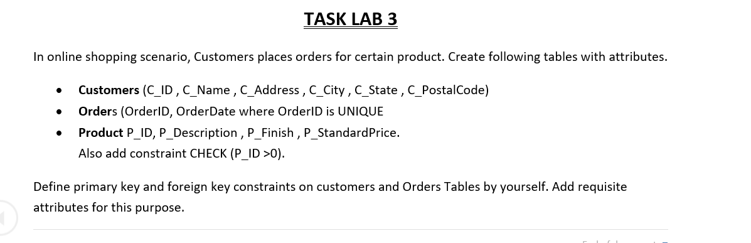

**Code:**

CREATE TABLE Customers9 (

C_ID INT PRIMARY KEY,

C_Name VARCHAR(255),

C_Address VARCHAR(255),

C_City VARCHAR(255),

C_State VARCHAR(255),

C_PostalCode VARCHAR(255)

);

CREATE TABLE Orders9(

OrderID INT PRIMARY KEY,

OrderDate DATE DEFAULT GETDATE(),

C_ID INT,

FOREIGN KEY (C_ID) REFERENCES Customers9(C_ID)

);

CREATE TABLE Products (

P_ID INT PRIMARY KEY CHECK (P_ID > 0),

P_Description VARCHAR(255),

P_Finish VARCHAR(255),

P_StandardPrice VARCHAR(255)

);

select * from Customers9

select * from Orders9

select * from Products

